Partners Presentation

256 acre ,100% commercial. Waco TX.

Buy out Existing private Note of $16 millions.

20% returns every year , minimum hold 1 year, maximum hold 3 years.

BR Estates At Waco LLC
By
B3R Investments
https://b3rinvestments.com

256 Acres in the City of Waco, TX

google direction to property-> https://maps.app.goo.gl/BiqKgwPyhG8gnSmX8
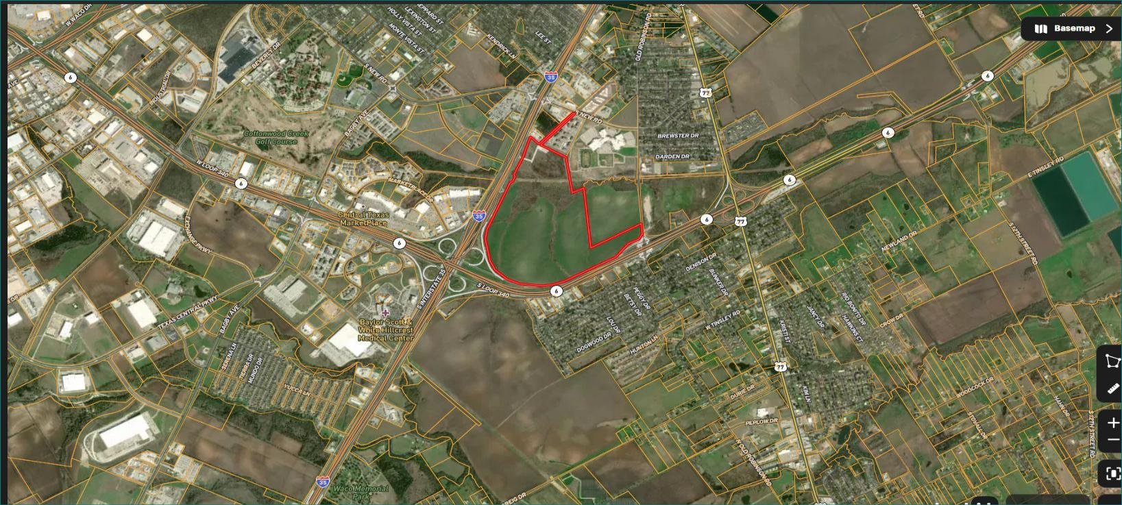
Opposite land listed for 150k acre,which is industrial , walmart bought 64 acres

already .

https://www.loopnet.com/Listing/Interstate-35-Robinson-TX/28731538/
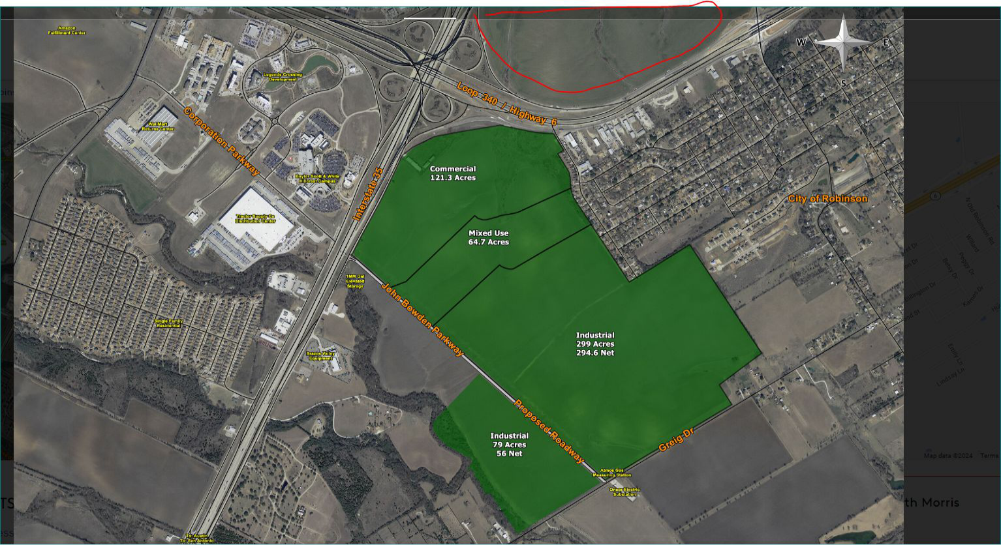

site
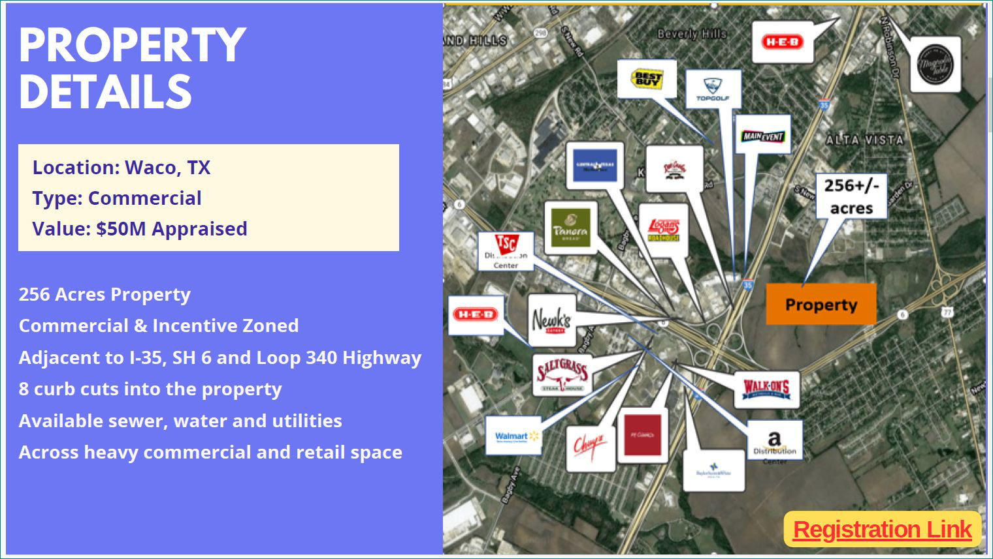

site
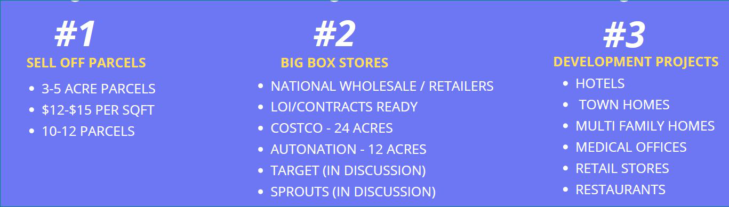

site
Why we need to invest in this property:

->20% of amount accumulates every year upto 3 years. At 36th month ,160% returns to investors.

-> Land is appraised for 50 millions, $16 millions collecting to pay off private lender Note.

-> We are the first Lien holder.

-> if land owner default ,we will take over land and sell the land, until sale , Interest is accumulate every day.

->If partial land sale , landowner will pay 75% of the amount of sale to us first.

->Payoff the 100% amount before 75% of land being sold.

-> Amount is required in July 1st week.

-> Already Costco ,AutoNation submitted LOI.

->Water ,Sewer already in place. City willing to give any permission.

->minimum $50k cash.

->$62,500 per acre we are going as lien holder, Owners bought it for $108k per acre.
Contact:

Name: Raghu Raj Buchannagari

Phone: 913-481-2668 (text, whatsapp,voice)

Email : Raghu@B3RInvestments.com

Investment Whatsapp Group for upcoming projects,Join with link below.

https://chat.whatsapp.com/I6BbvTAJfwuEP0f6rT5Zlw

